Project Planning Phase
Project Planning Template (Product Backlog, Sprint Planning, Stories, Story points)

Date | 30 September 2026
Team ID | SWTID-2026-9545
Project Name | Import Data using Transform Maps (Spreadsheet) – ServiceNow
Maximum Marks | 5 Marks

Planning approach:
- Sprint: a fixed period in which the team completes a set of tasks (6 days each).
- Epic: a large piece of work broken into smaller stories.
- Story: a small task that belongs to an epic.
- Story Point: effort estimate using the scale 1, 2, 3, 5 (1 = very easy, 2 = normal, 3 = moderate, 5 = difficult).
Product Backlog, Sprint Schedule, and Estimation (4 Marks)
Sprint | Functional Requirement (Epic) | User Story Number | User Story / Task | Story Points | Priority | Team Members
Sprint-1 | Data Preparation | USN-1 | Prepare the employee spreadsheet and download as .xlsx | 2 | High | [Member]
Sprint-1 | Target Table | USN-2 | Create custom table Employee Test (u_employee_test) | 2 | High | [Member]
Sprint-1 |  | USN-3 | Add Employee ID, Name, Email, Department and Location fields | 1 | High | [Member]
Sprint-1 | Data Import | USN-4 | Load the spreadsheet into Import Set table u_employee_import | 2 | High | [Member]
Sprint-1 |  | USN-5 | Create Transform Map and map the five fields | 3 | High | [Member]
Sprint-1 |  | USN-6 | Run the transform and validate records in Employee Tests | 2 | High | [Member]
Sprint-2 | Duplicate Prevention | USN-7 | Enable Coalesce on Employee ID | 3 | High | [Member]
Sprint-2 |  | USN-8 | Re-import changed data and verify inserts, updates and ignored rows | 2 | High | [Member]
Sprint-2 | Reporting | USN-9 | Report 1: Employees by Department (Pie) | 2 | Medium | [Member]
Sprint-2 |  | USN-10 | Report 2: Employees by Location (Bar) | 2 | Medium | [Member]
Sprint-2 |  | USN-11 | Report 3: Employee List Report (List) | 2 | Medium | [Member]
Sprint-2 | Dashboard | USN-12 | Enable ACL admin override and create Employee Analytics Dashboard | 3 | Medium | [Member]
Sprint-2 |  | USN-13 | Add the three reports to the dashboard and review sharing | 2 | Medium | [Member]

Story point totals:
Sprint-1 = 2 + 2 + 1 + 2 + 3 + 2 = 12
Sprint-2 = 3 + 2 + 2 + 2 + 2 + 3 + 2 = 16
Total story points = 12 + 16 = 28
Project Tracker, Velocity & Burndown Chart: (4 Marks)
Sprint | Total Story Points | Duration | Sprint Start Date | Sprint End Date (Planned) | Story Points Completed (as on Planned End Date) | Sprint Release Date (Actual)
Sprint-1 | 12 | 6 Days | 19 Jan 2026 | 24 Jan 2026 | 12 | 19 Jan 2026
Sprint-2 | 16 | 6 Days | 26 Jan 2026 | 31 Jan 2026 | 16 | 29 Jan 2026

The actual release dates follow the timestamps recorded in ServiceNow for the first transform (19 Jan 2026) and for the re-import, reports and dashboard work (29 Jan 2026).
Velocity:
Velocity = Total story points completed ÷ Number of sprints = 28 ÷ 2 = 14 story points per sprint.
Average velocity per day = 14 ÷ 6 days ≈ 2.33 story points per day.
Burndown Chart:
A burndown chart shows the work left to do versus time. The chart below plots the planned (ideal) and the sprint-wise remaining story points.
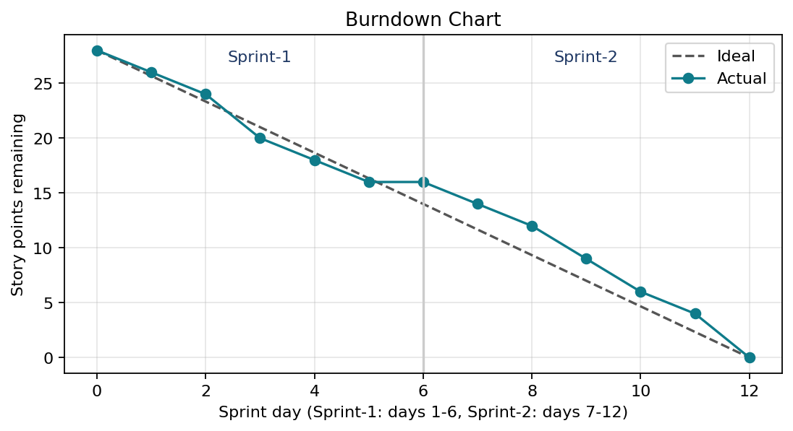
Figure 1: Burndown chart for Sprint-1 and Sprint-2 (illustrative, based on the sprint plan)
Reference: https://www.atlassian.com/agile/tutorials/burndown-charts

